McMaster University

Dept. of Electrical and Computer Engineering

COMP ENG 4TL4 - Term I (Fall) 2023

# **Lab 2 - Discrete Time Fourier Analysis and Sampling**

**Demo Date: Oct .16**

**Due Date: Oct .22**

**Tianze zhang 40028135**

**Xiang li**

# [**zhant22@mcmaster.ca**](mailto:zhant22@mcmaster.ca)

# [**lix289@mcmaster.ca**](mailto:lix289@mcmaster.ca)

**Experiments:**

**1. Introduction to convolution:**

Part(a):

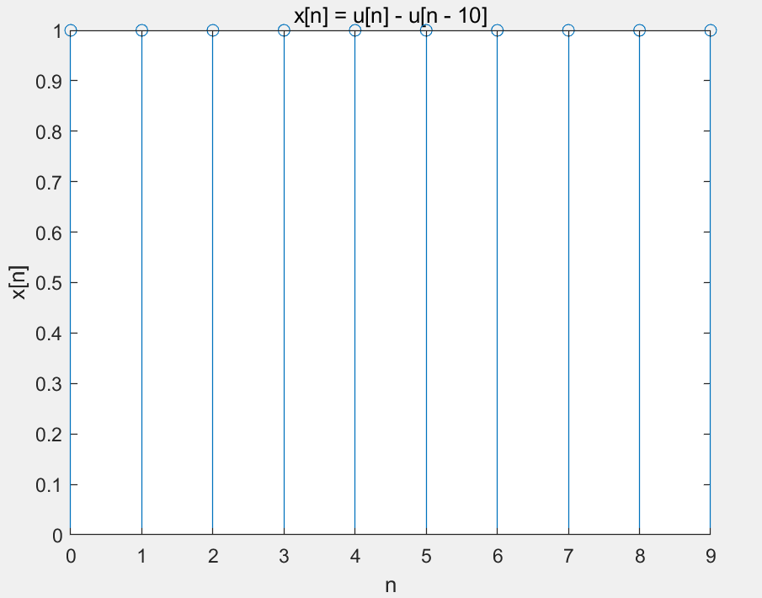

**Discussion:**

From above plot, as we have unit step function u[n], which from n =0 the value is 1, and u[n-10] which from n=10, the value is 1, so if we sunstract them, the x[n] is 1 when n<= 9 and zero afterward. With no zero-pad, we only show n from 0 to 9.

part(b)(c):

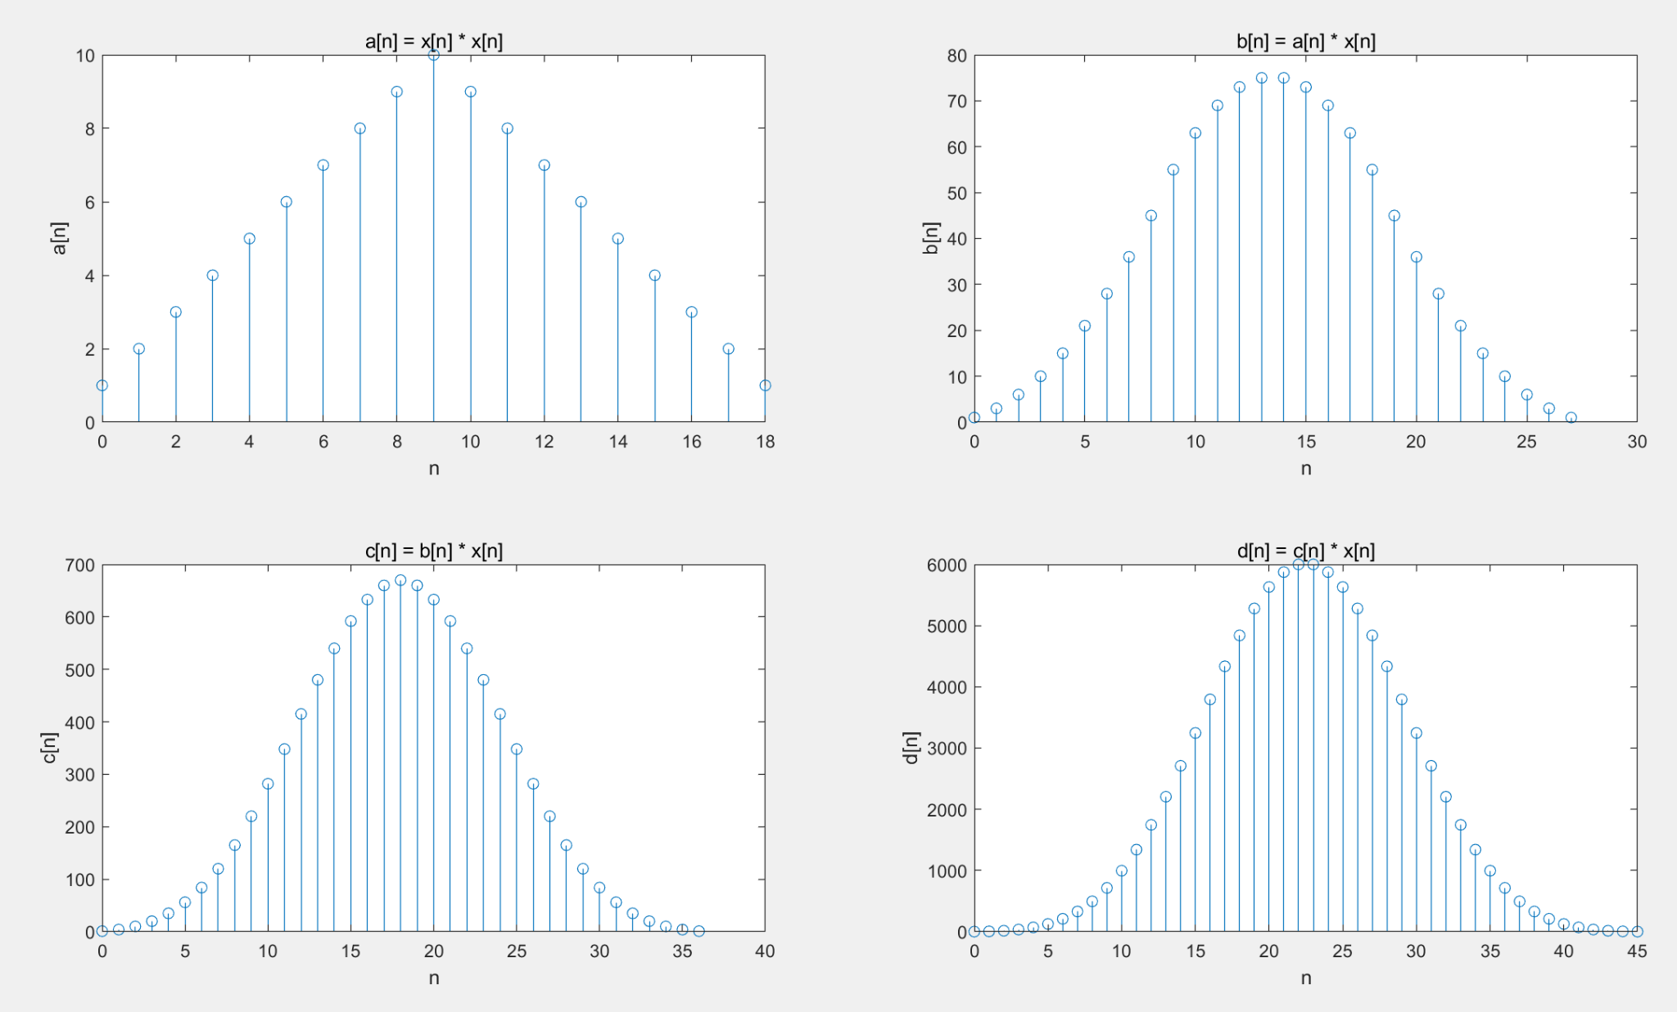

**Discussion:**

From the above plots we can see the effects of convolution, It computes the convolution of two sequences or signals. As that has been said, every iteration we convolute the signals, the amplitude increases exponentially. The number of n needs to sample all the discrete points increase as well.

**2. Convolution of signals and system impulse responses:**

**part(a)(b):**

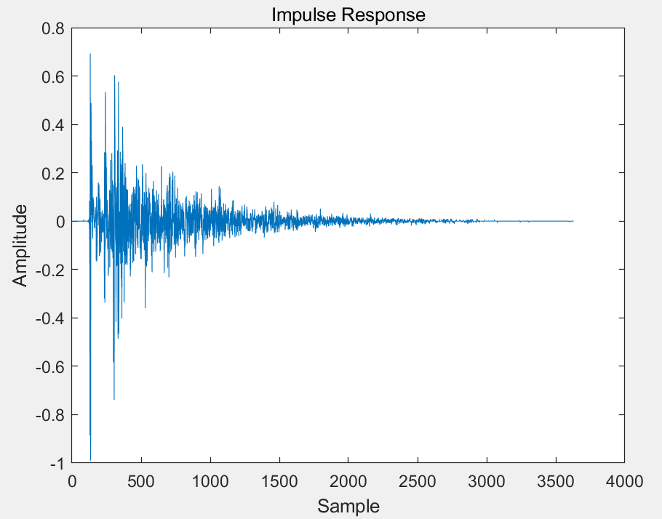

**discussion :**

Above plot is the impulse response, from the audio file, we assume it is the sound of clap inside a room.

**part(c)(d):**

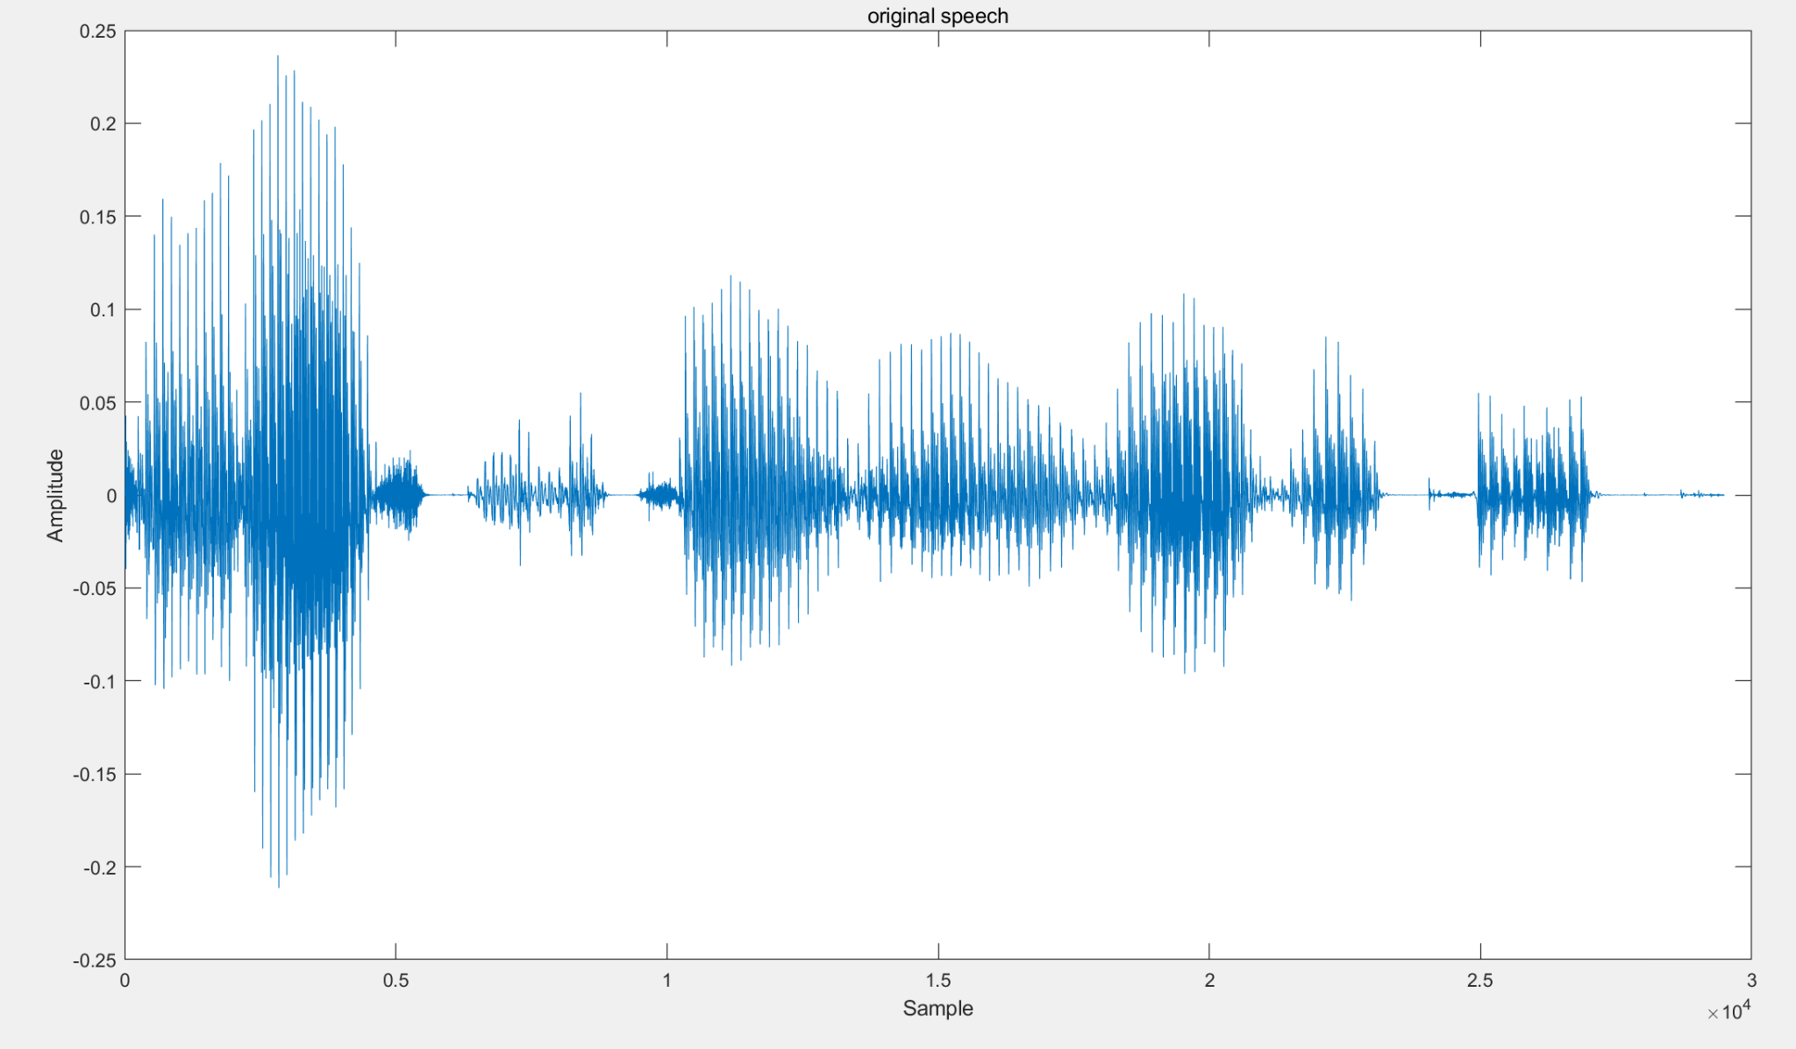

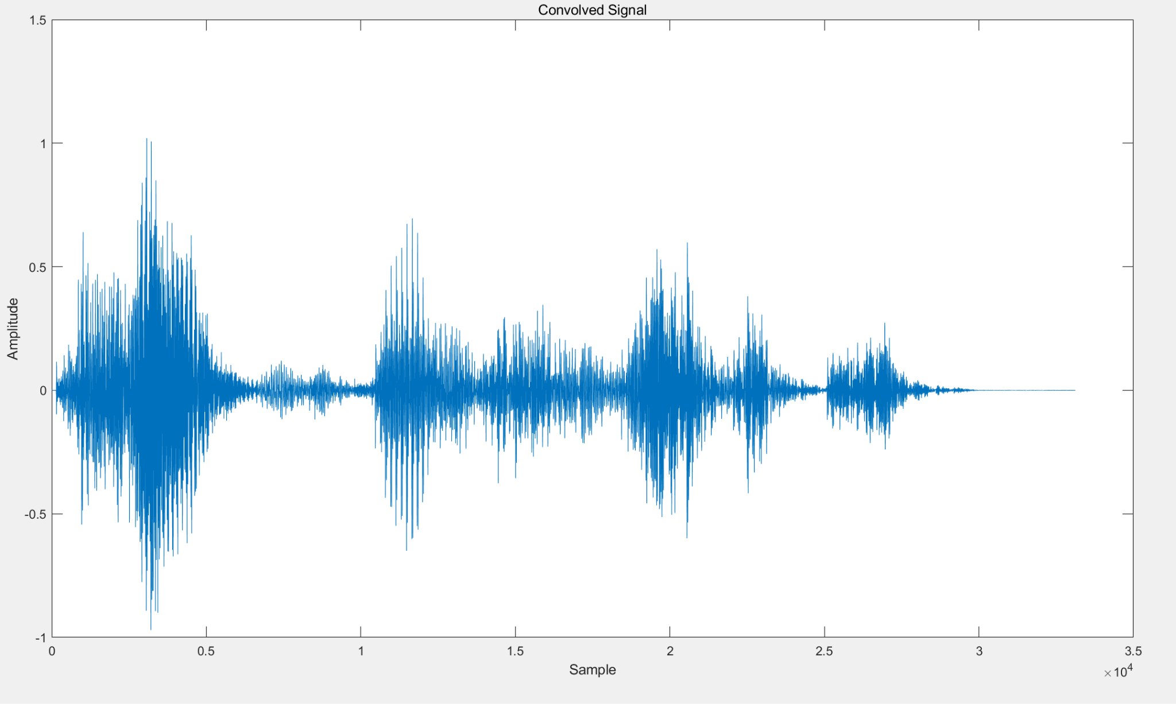

**discussion :**

For the impulse response waveform, when I listen to it, I hear reverberation or echoes. This is due to the space reacting to an impulsive sound source is typified by this impulse reaction. From the plot we can see a sequence of peaks and troughs that indicate the room's acoustics and reflections.

Convolution of the voice signal with the impulse response of the room yields the convolved signal. I found out that the original speech signal is "colored" by the acoustic properties of the environment. After the convolved signal has been subjected to the acoustics of the room.

The convolved signal essentially reproduces the speech as it would sound if it were captured in the room that the impulse response describes. It captures the original speech signal's influence from the room's acoustics.

The content of the speech might be: “don’t ask me to carry all the rag like that”

**3. The Discrete-Time Fourier Transform (DTFT):**

part(a)(b)(c):

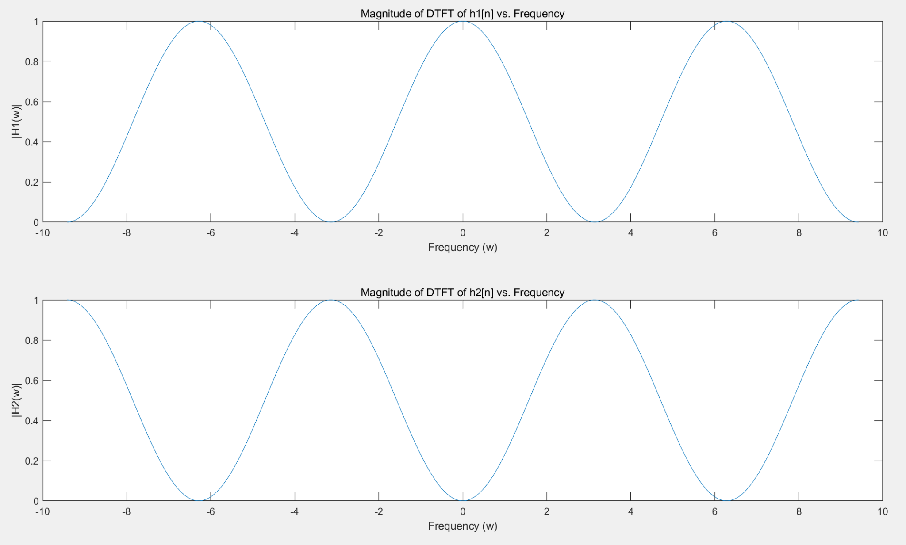

**discussion :**

We use formula DTFT(X(ω)) = Σ [x[n] * e^(-jωn)] to convert impulse responses to DTFTS, The resulting DTFT is as followed:

H1= (1/4)e^(-jω0) + (1/2)e^(-jω1) + (1/4)e^(-jω2)

H2 = = (-1/4)e^(-jω0) + (1/2)e^(-jω1) - (1/4)e^(-jω2)

Since the resulting DTFTs involve complex exponential functions, they are complex-valued. Typically, a complex-valued function of frequency ω is the output of a DTFT. Given that it depicts the system's frequency response, a complicated value is anticipated.

Both periodicities of the DTFT are 2π. When the frequency increases from 0 to 2π, it will include the whole frequency spectrum. This property is fundamental and doesn't depend on the specific shape of the signal. So, no matter how the signal looks, the period of the DTFT in the frequency domain is always 2π, and it repeats every 2π radian.

**Part 4:**

**Without downsampling:**

Fs = 8000 f1=1000 f2=3000 f3 =1000

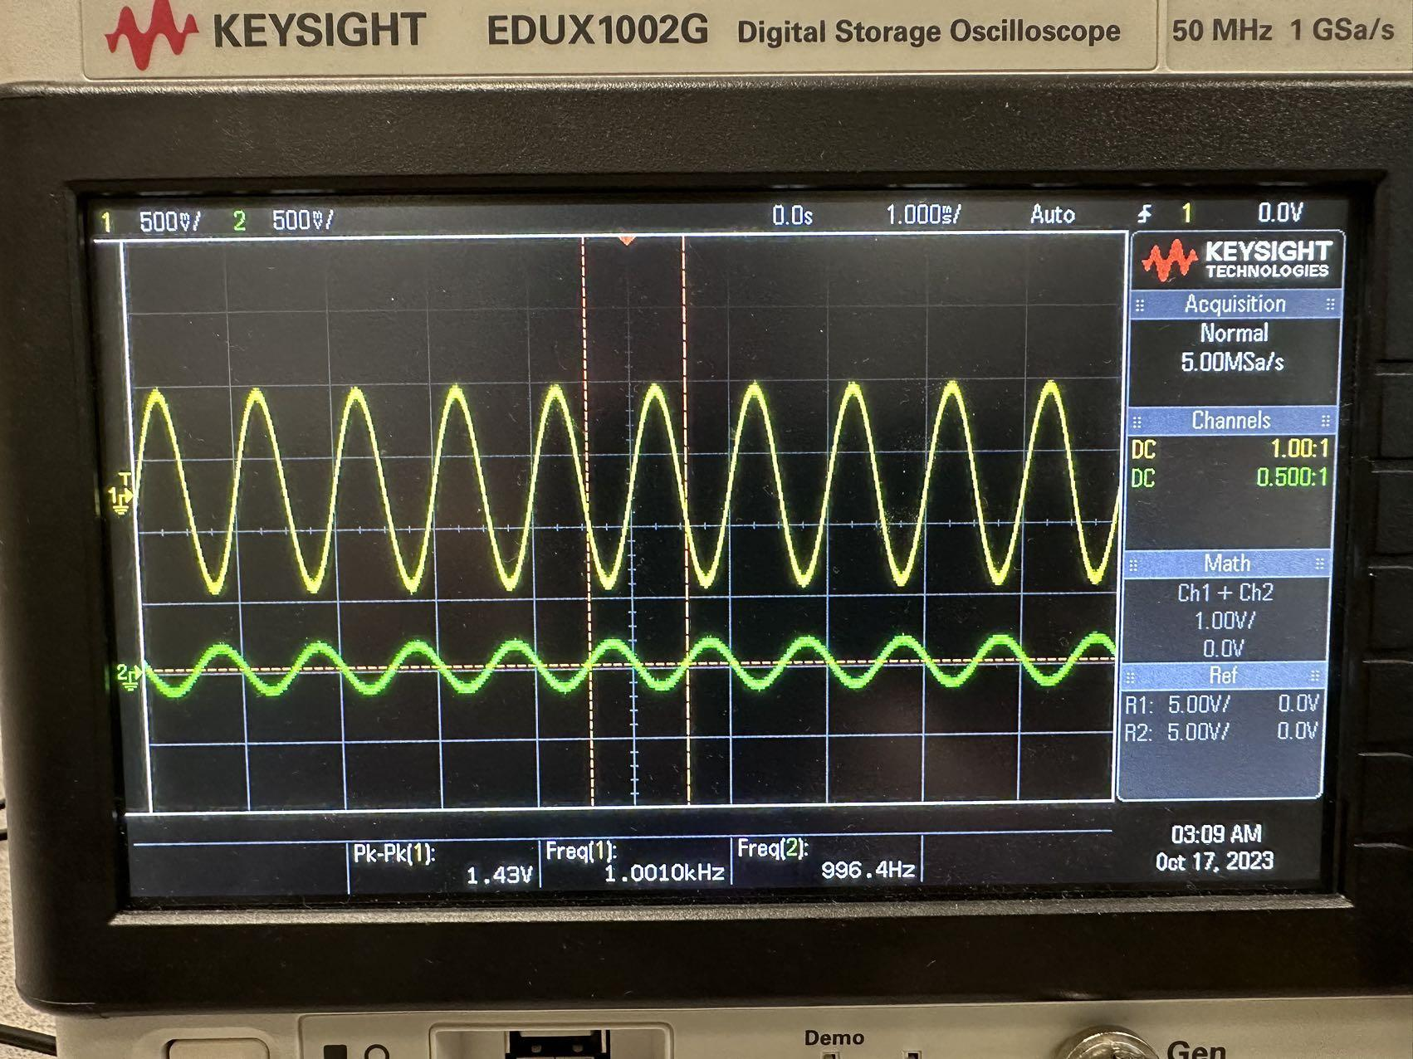

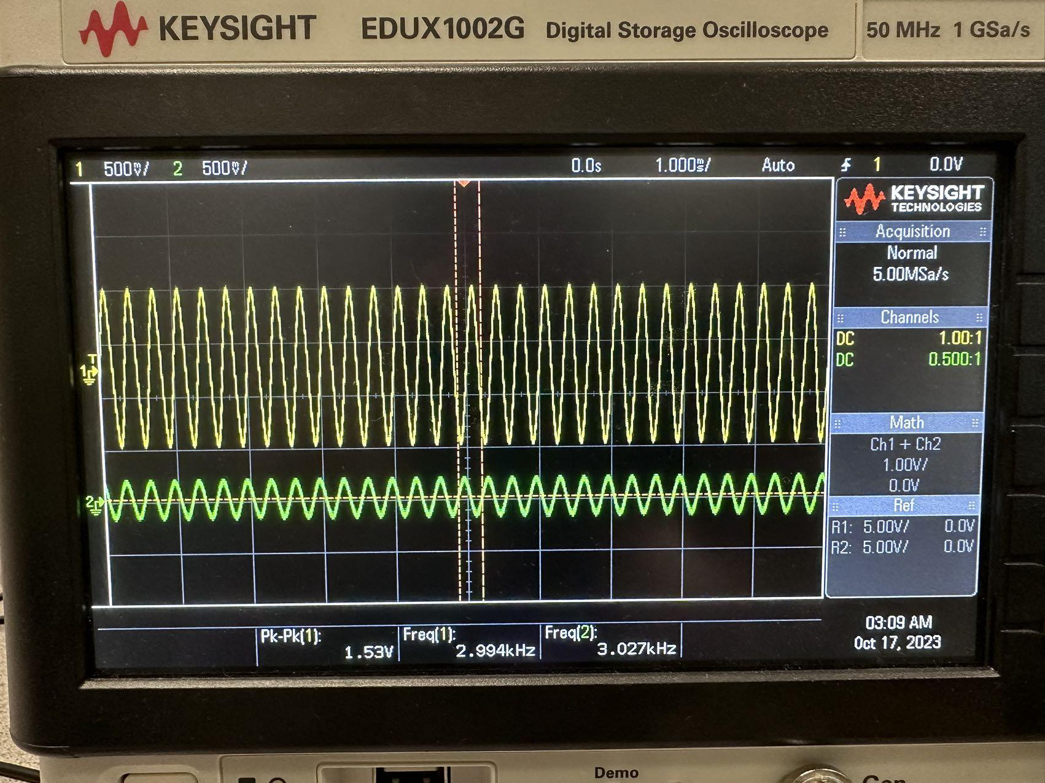

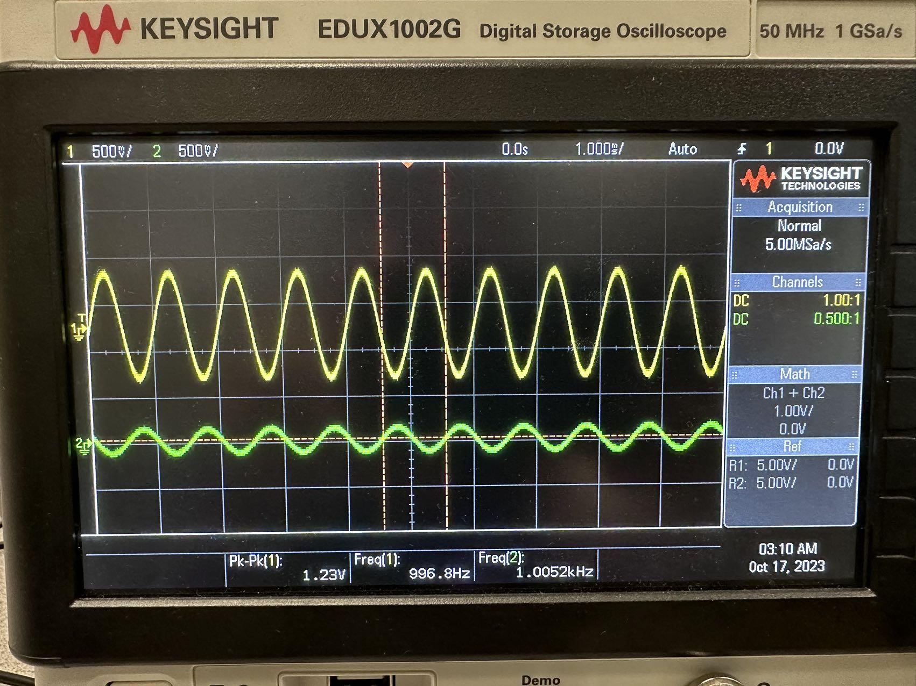

Fs = 8000 f1=1000 f2=5000 f3 =1000

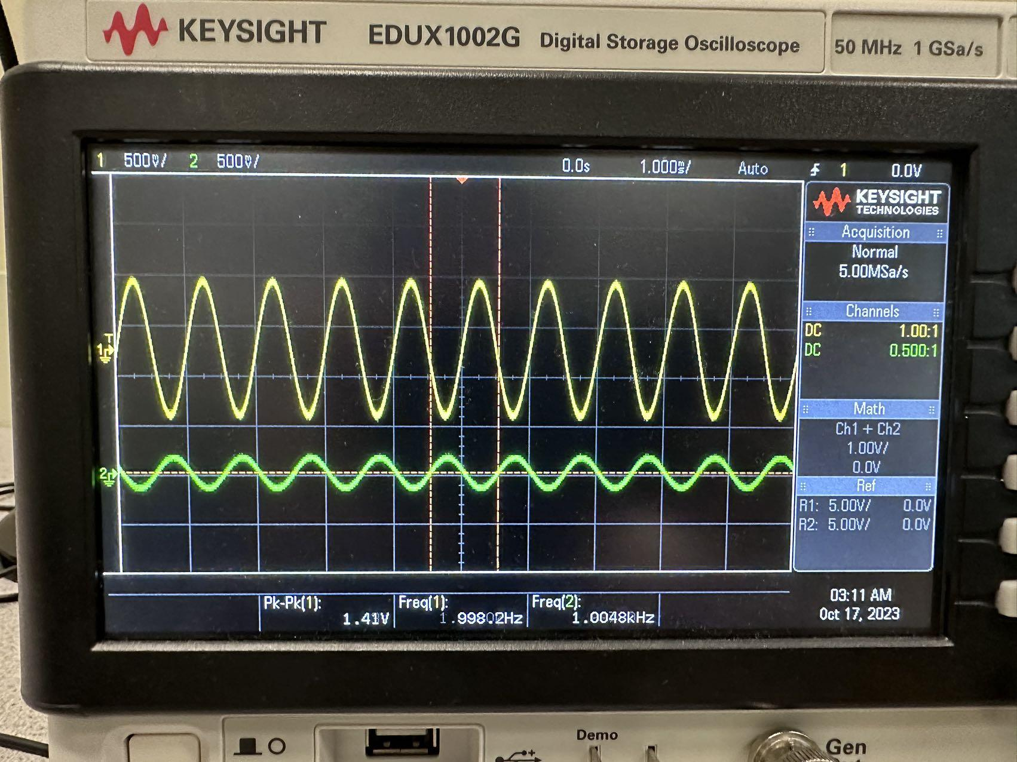

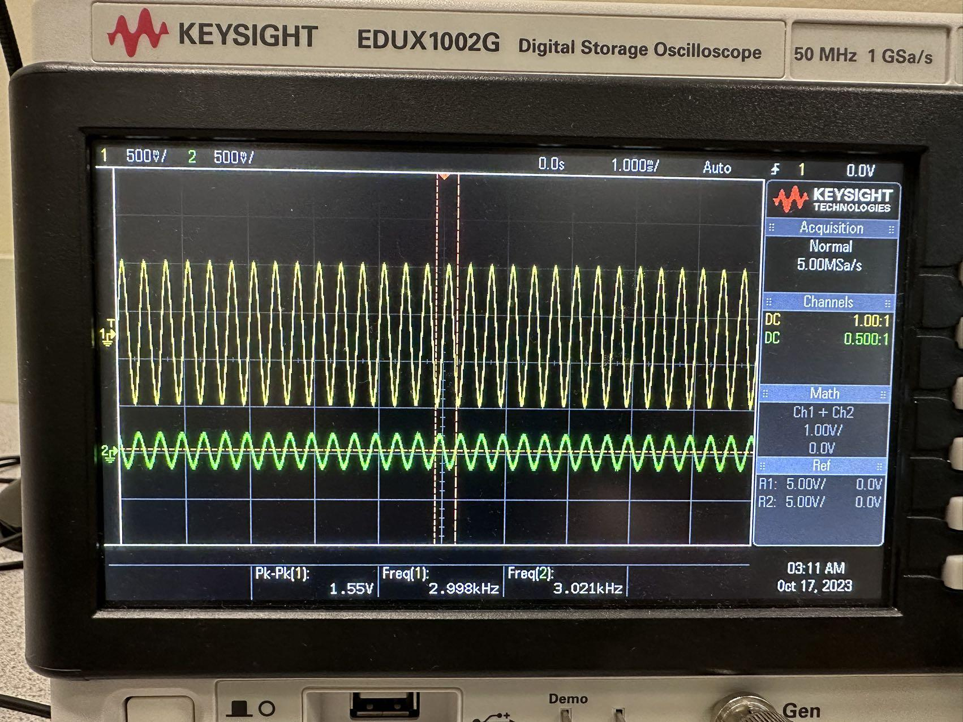

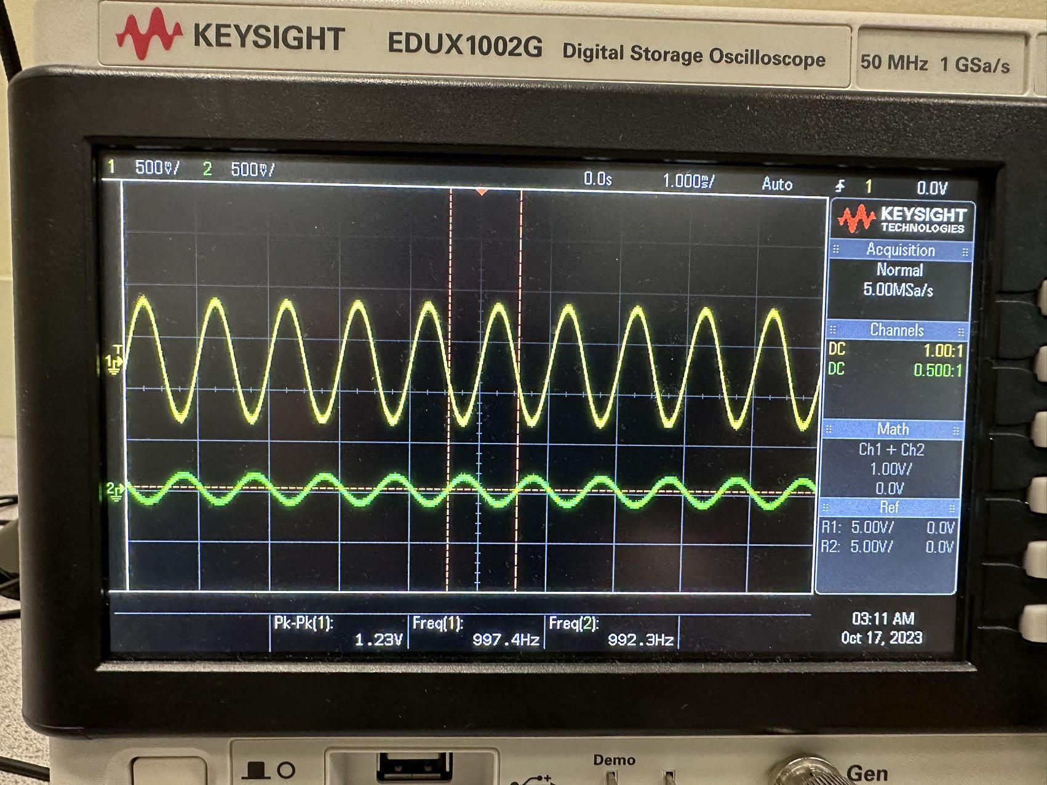

Fs = 16000 f1=1000 f2=5000 f3 =1000

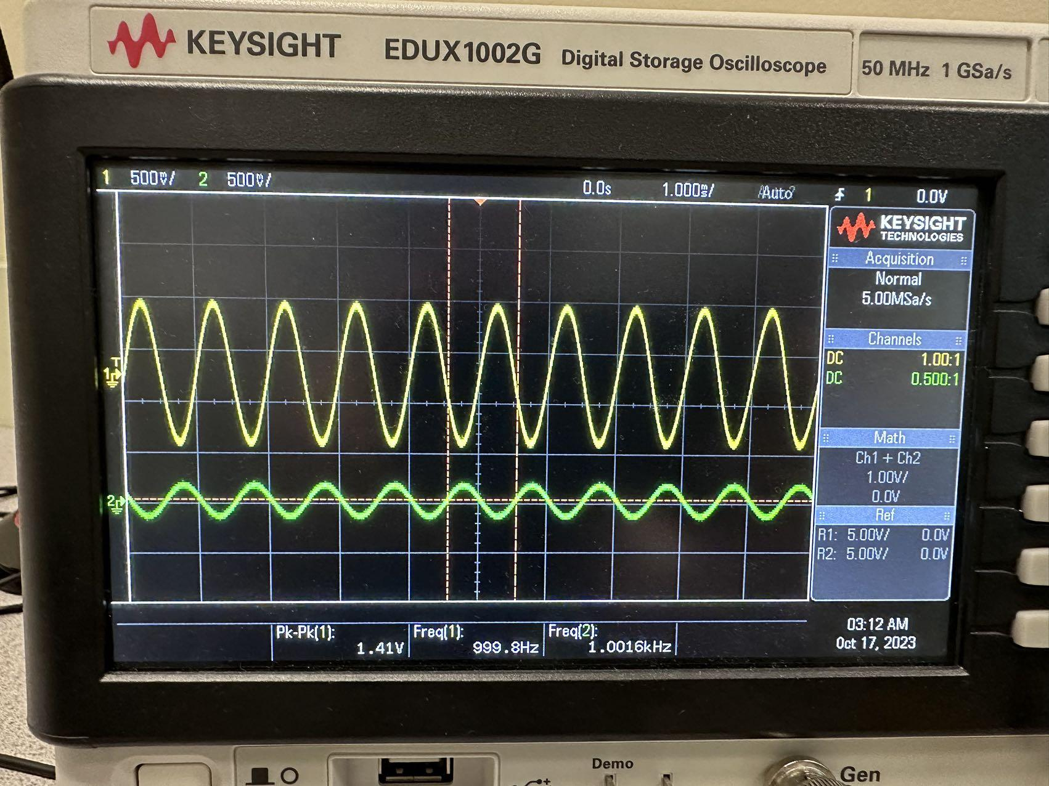

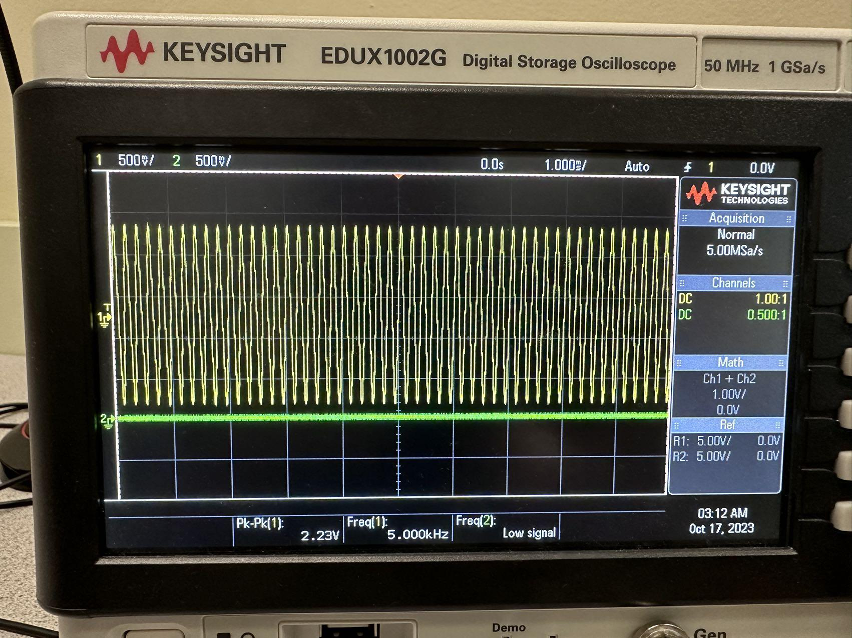

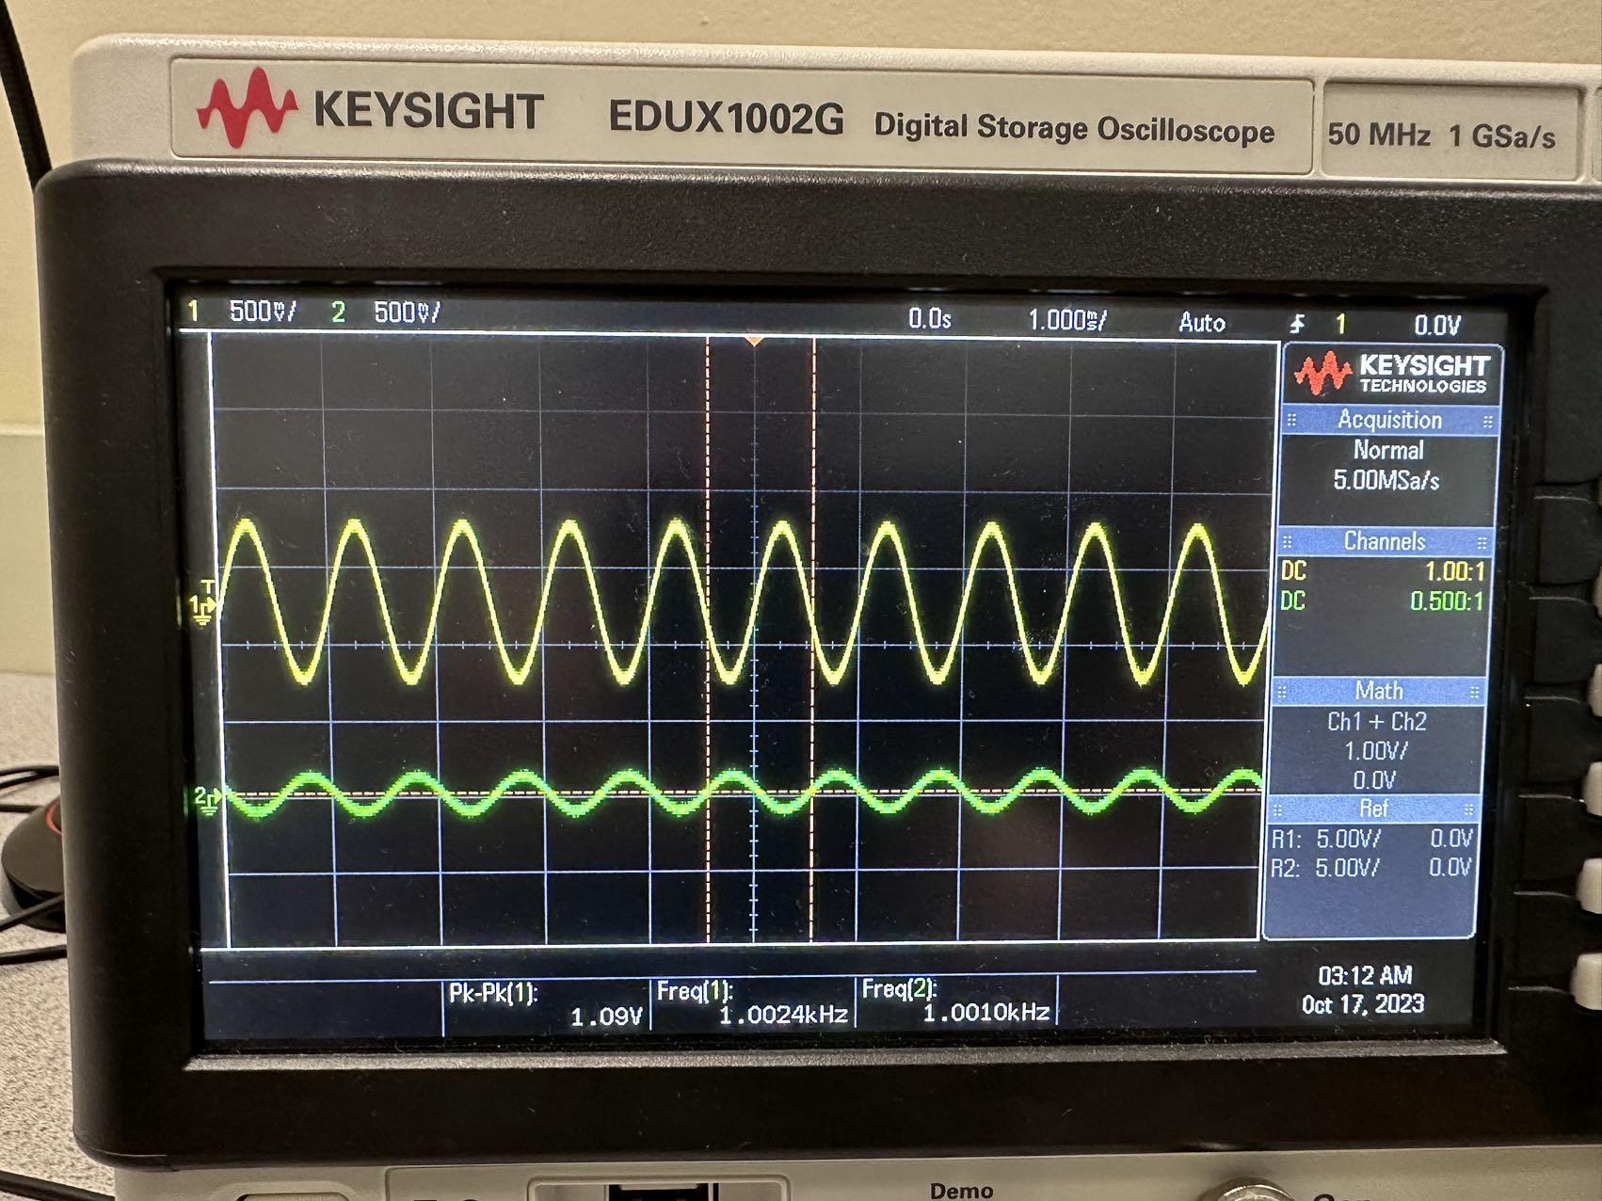

**with downsampling:**

Fs = 8000 f1=1000 f2=3000 f3 =1000

With down sampling, the fs is divide by 2 so the Fs = 4000.

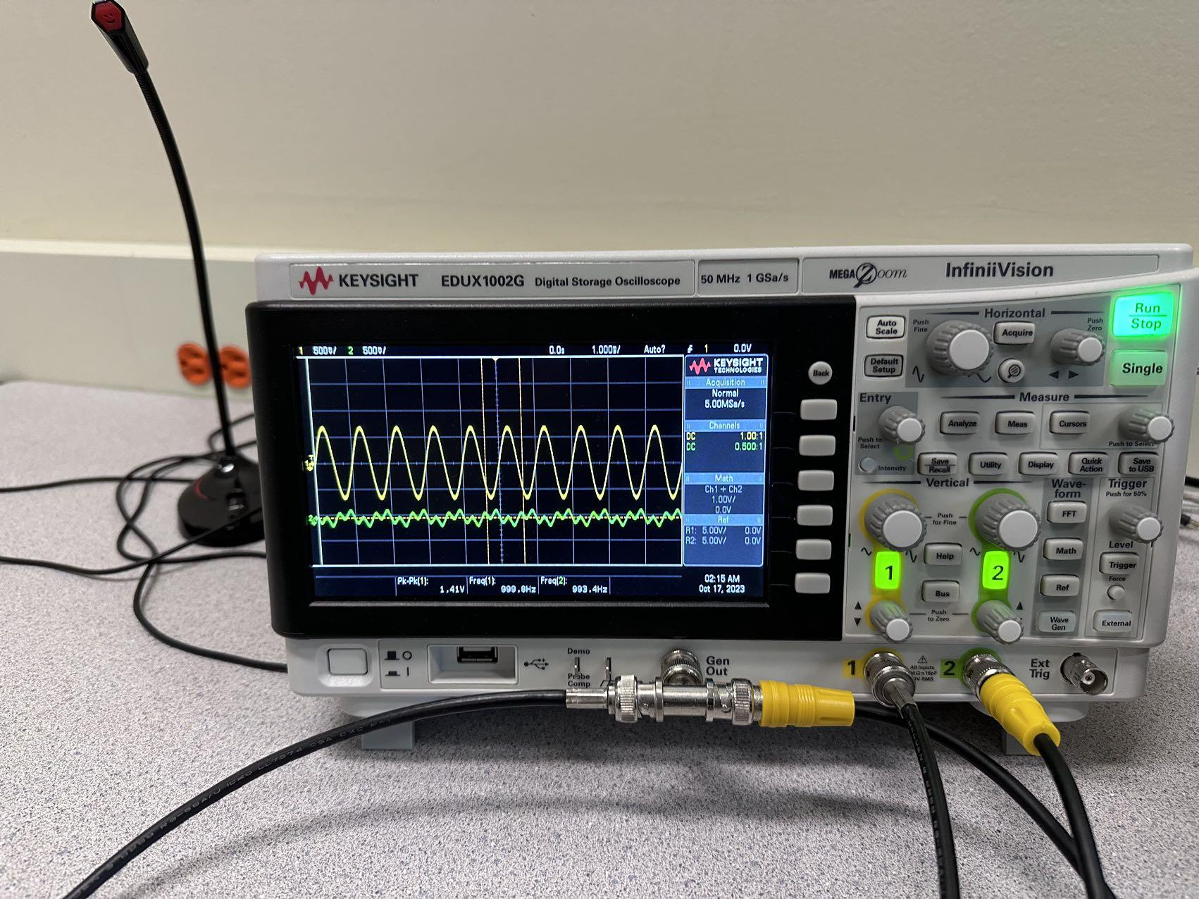

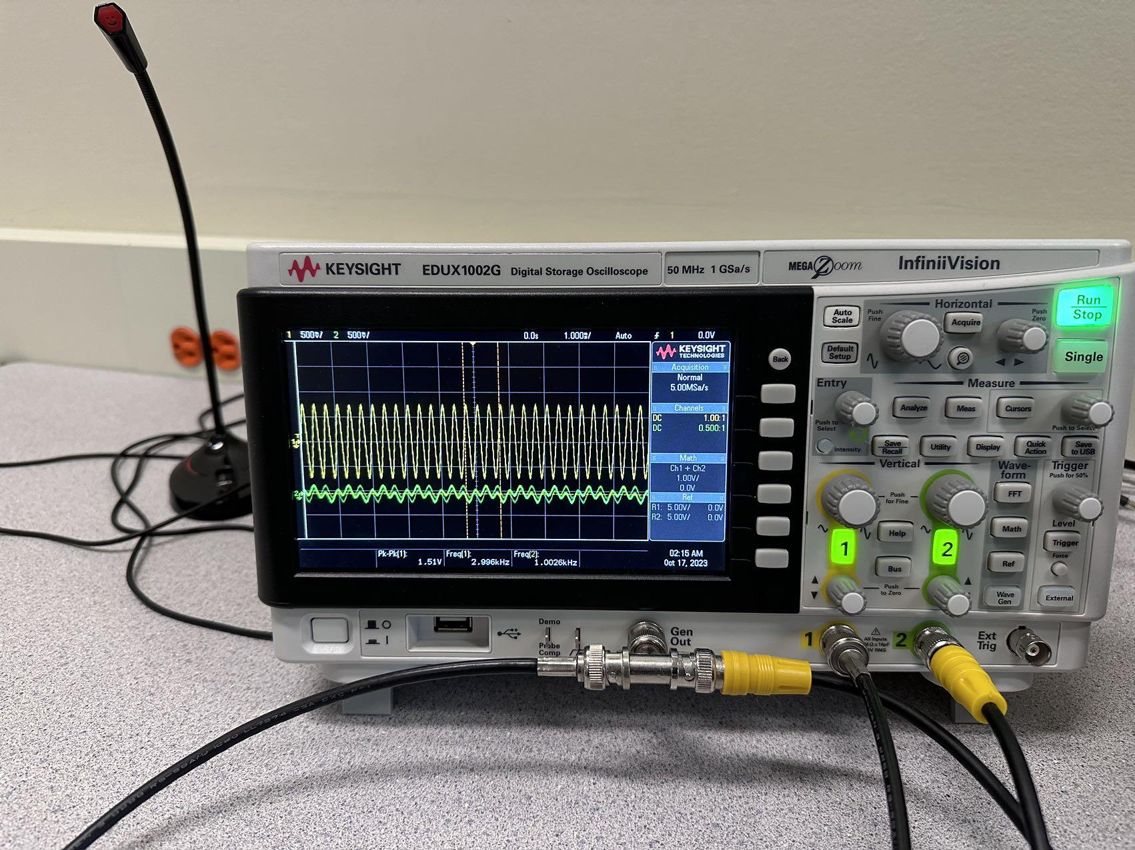

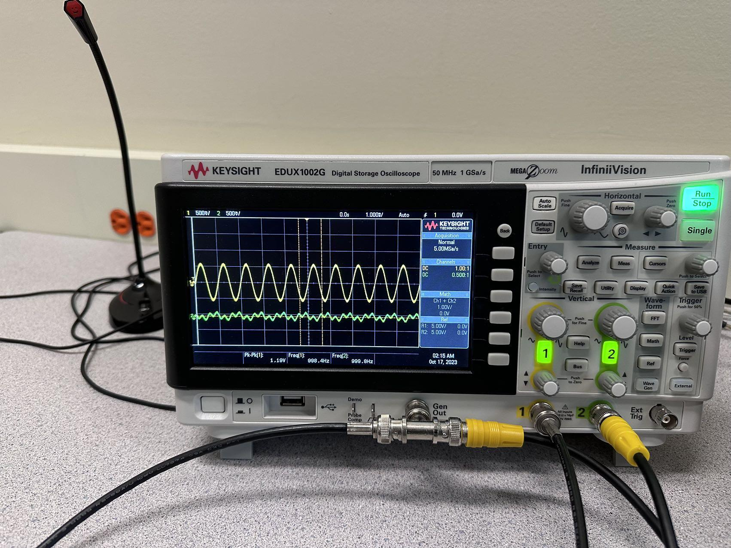

Fs = 8000 f1=1000 f2=5000 f3 =1000

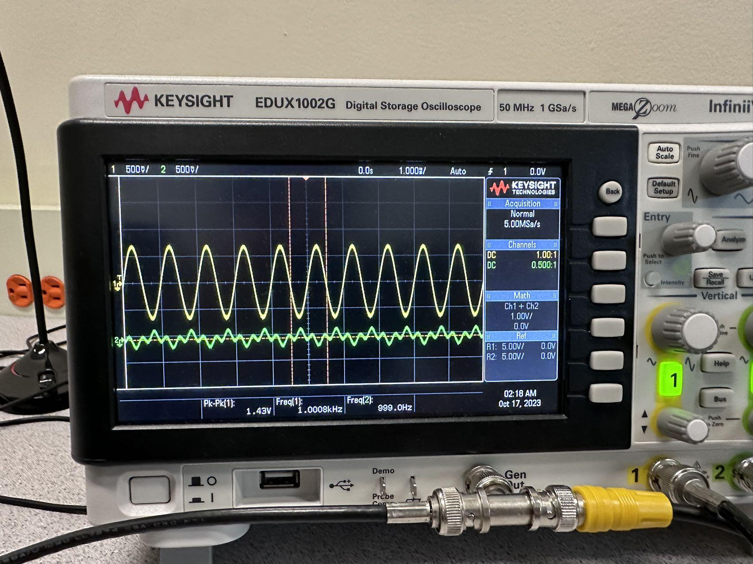

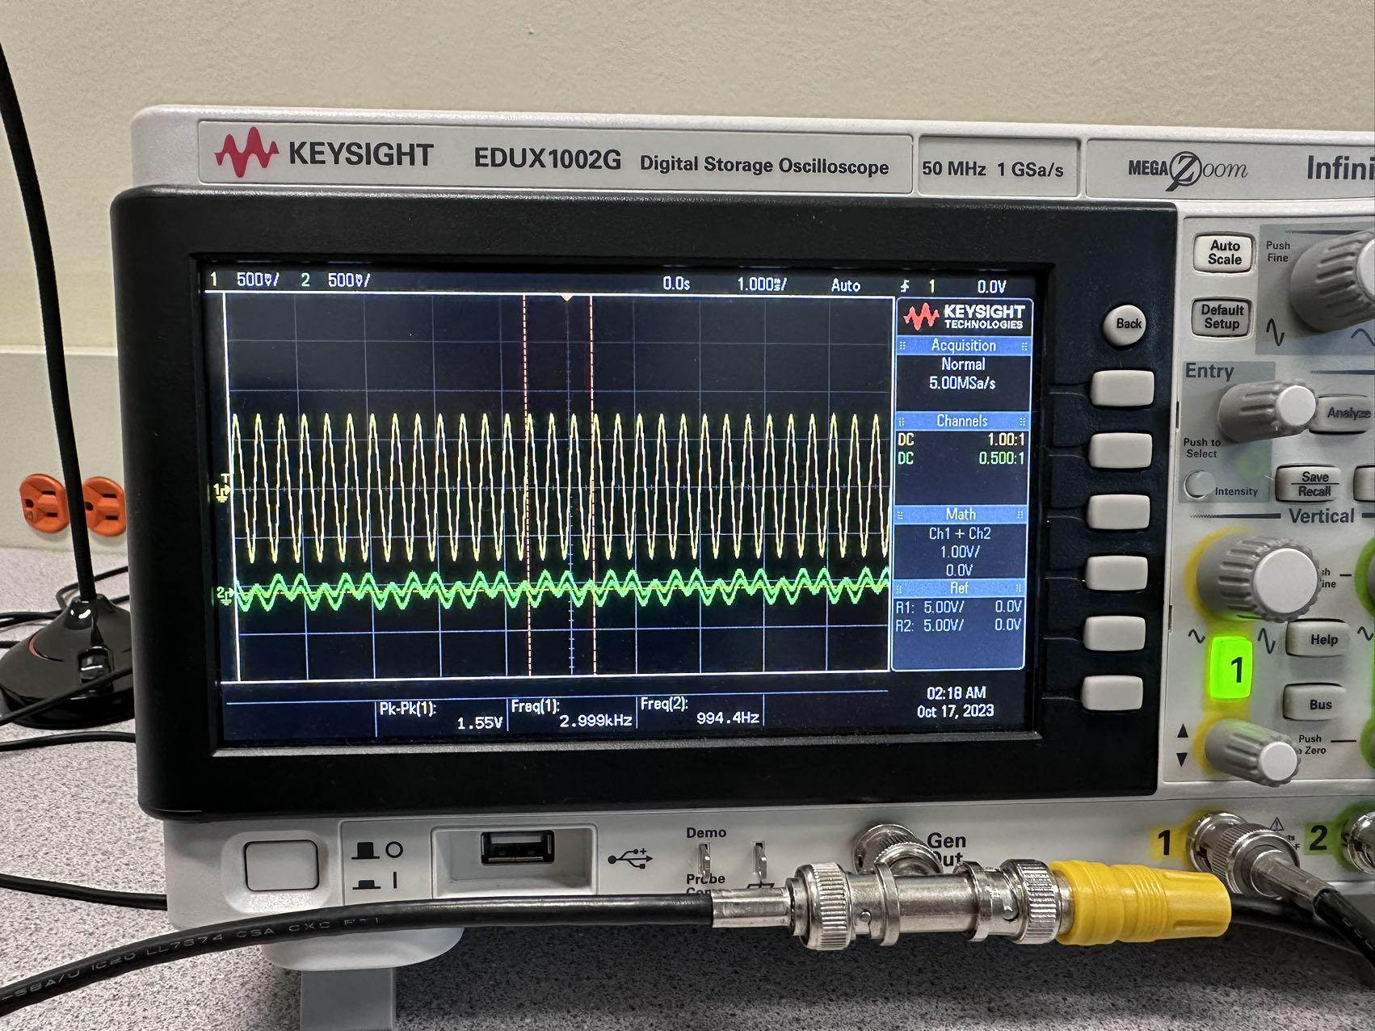

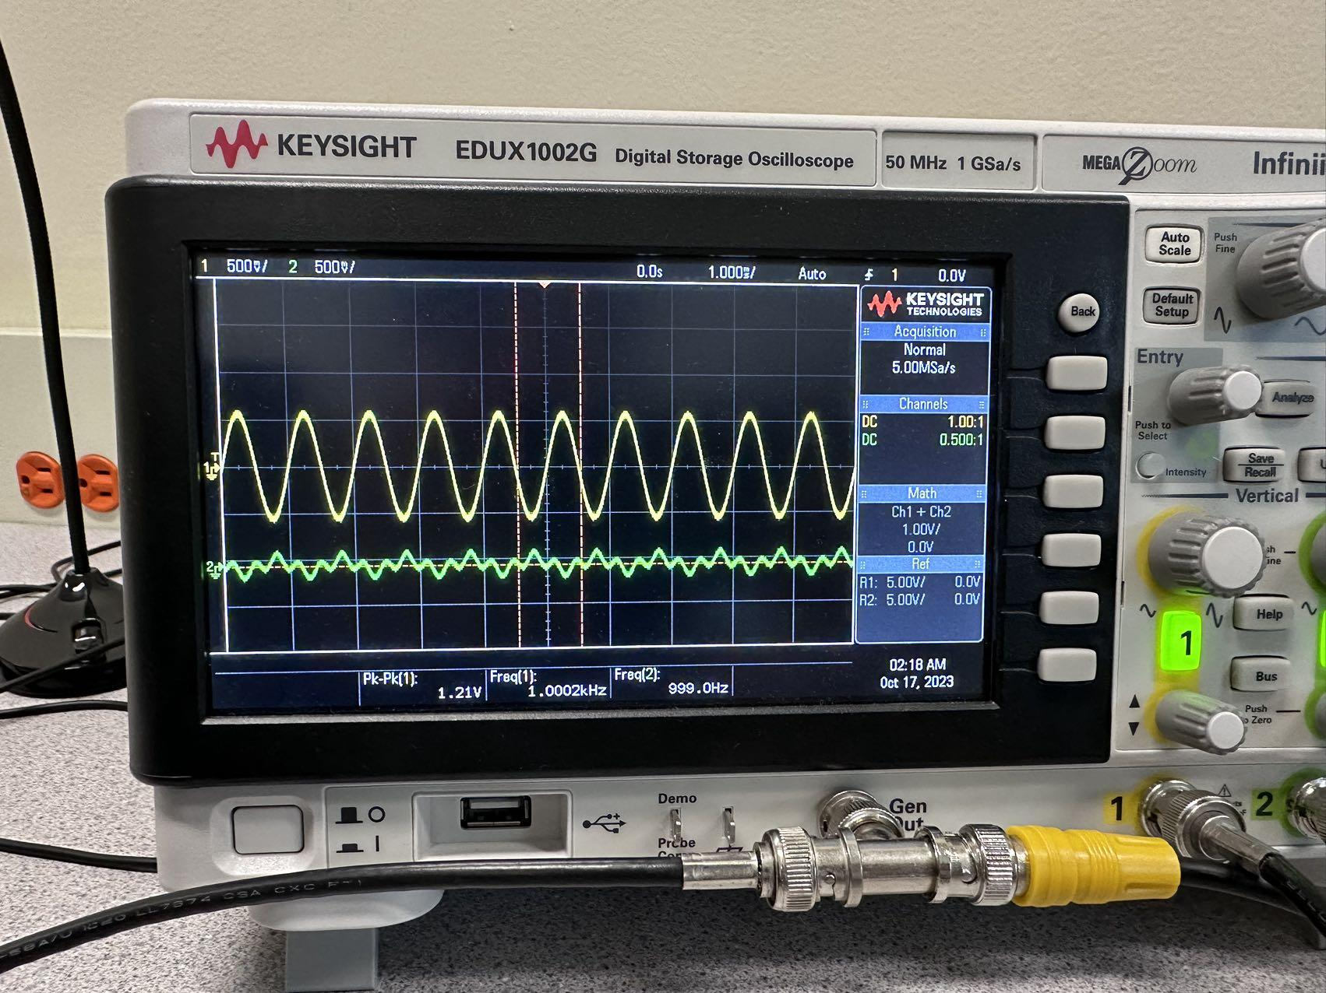

Fs = 16000 f1=1000 f2=5000 f3 =1000

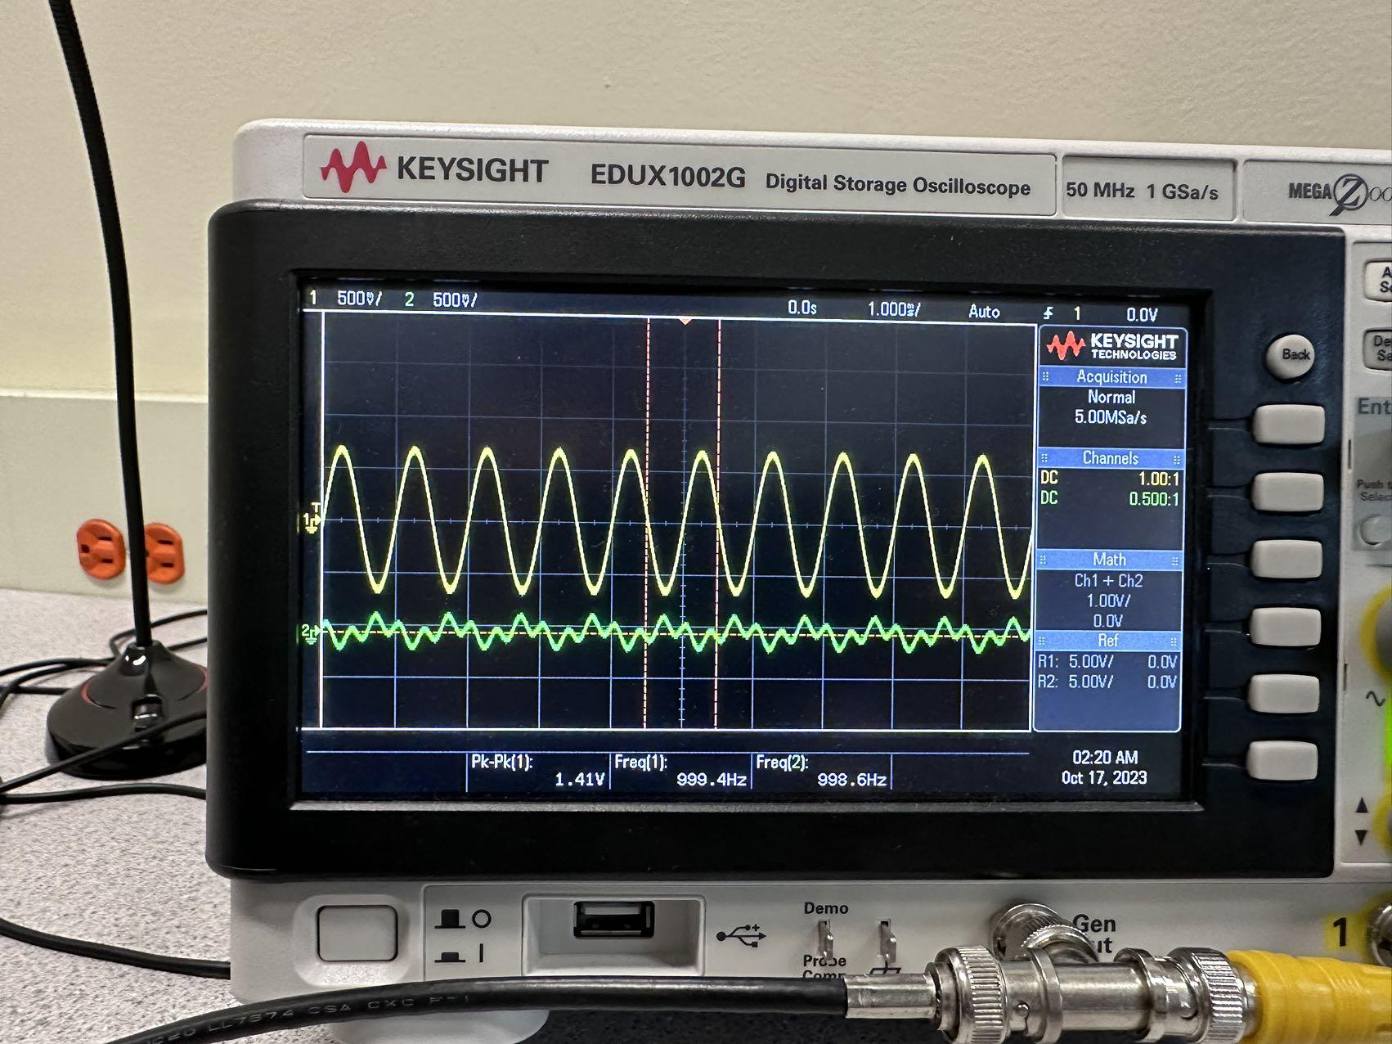

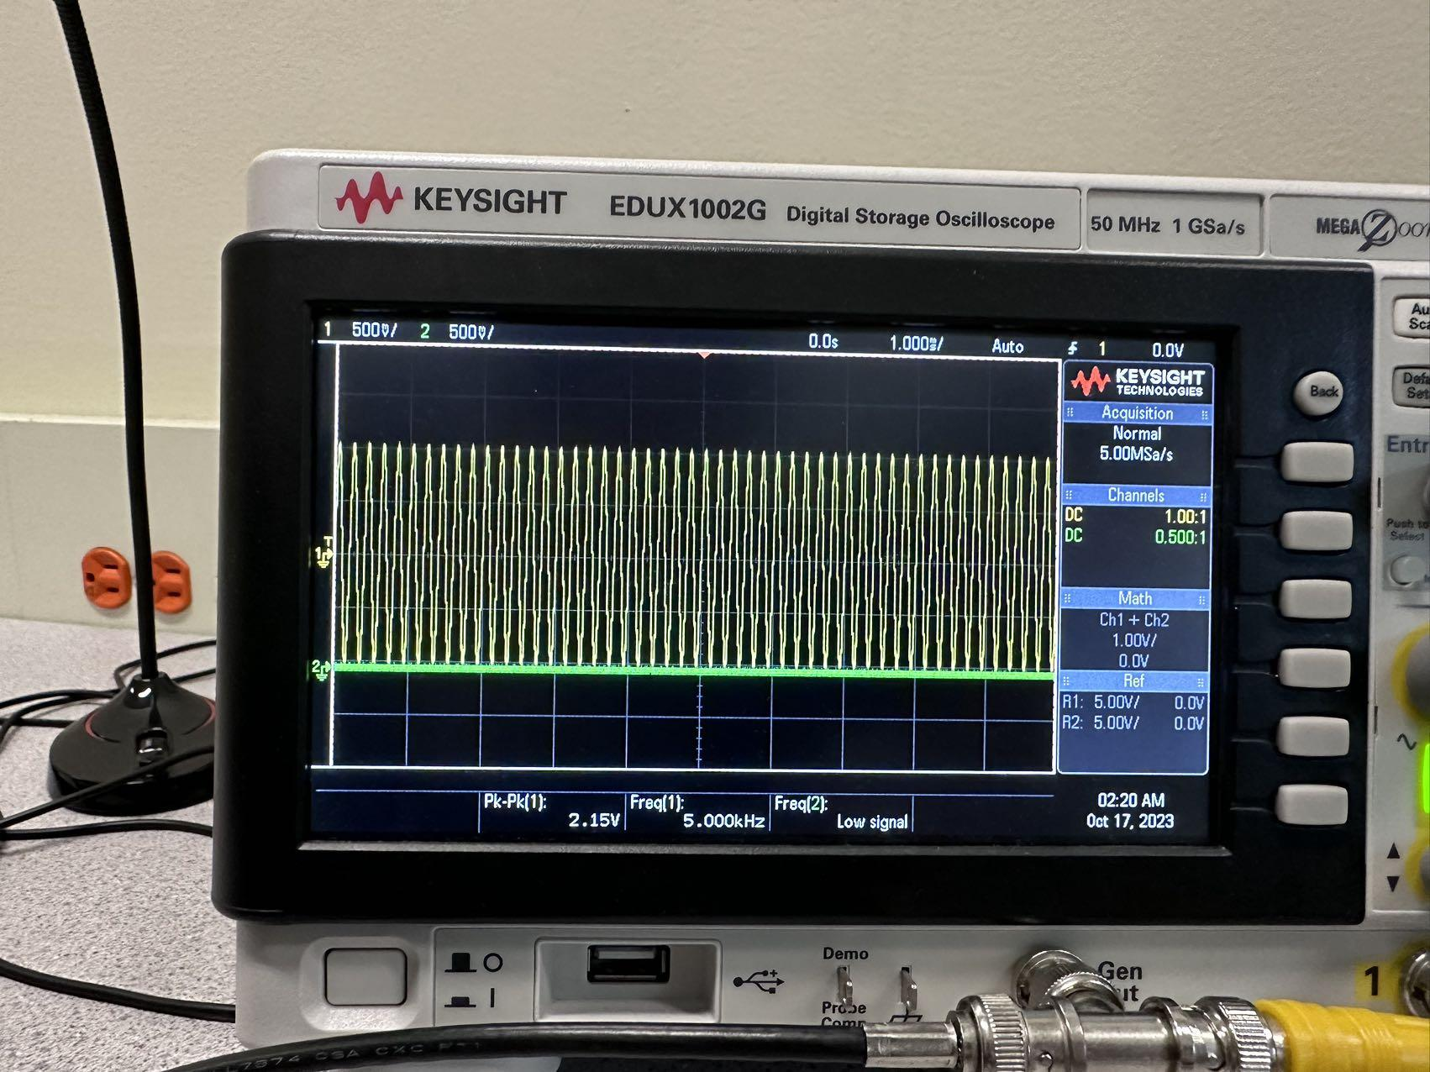

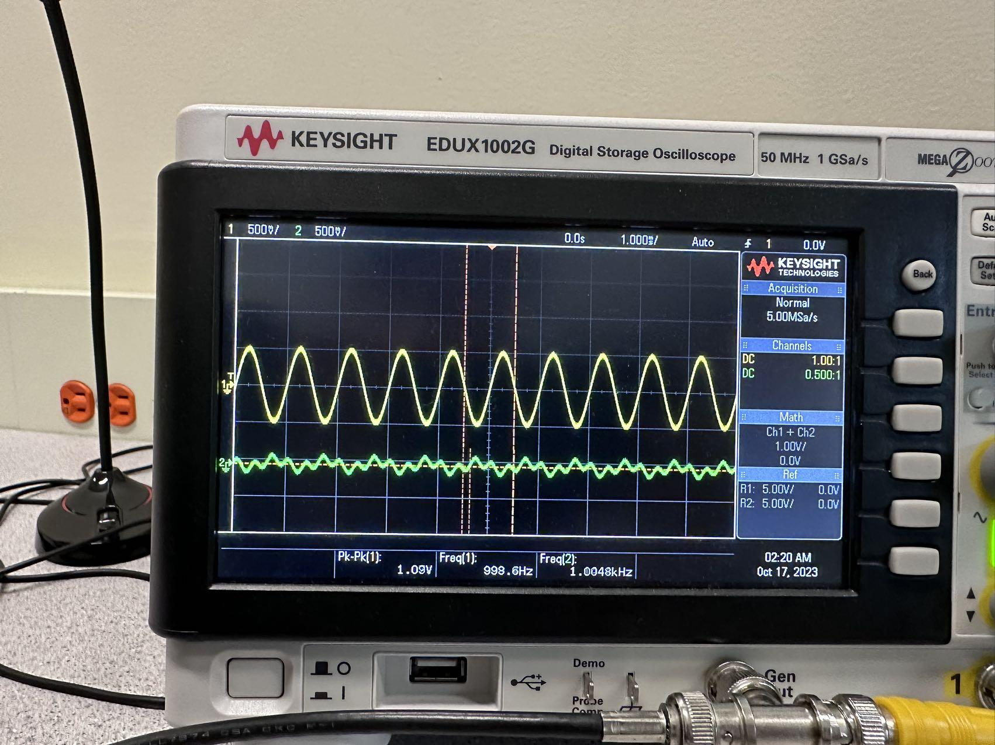

Discussion :

As we can see from Fs = 8000 f1=1000 f2=5000 f3 =1000 with downsampling, the plot is still aliasing, but we have Fs = 8000, f2 = 5000, why is aliasing still happening? Because with downsizing, the F2 is divided by 2, so the Fs right now is 4000, so in order to sampling f2 = 5000, we need at least 2*5000 = 10000 to sample the f2 perfectly.